 HISD Connect: Mentor Activity System

Data Flow Architecture

&

REST(OData) Services Implementation

Version – 2.0

Published: 11/01/2017

Author: Rezaul Raju

|  |
| --- |
| Confidentiality / Security Warning |
| *This is an internal HISD project document, and is not intended for viewing by any parties’ other than HISD employees, or HISD-designated actors that are specifically involved in this project. Intellectual property contained in this document is property of HISD, and is not intended for distribution.* |

**Change History**

|  |  |  |  |
| --- | --- | --- | --- |
| **Version** | **Date** | **Changed By** | **Description** |
| 1.0 | 06/22/2017 | Luis Quintero | Initial draft |
| 1.1 | 07/18/2017 | Rezaul Raju | Review of API/s based on till date system architecture |
| 1.2 | 09/11/2017 | Rezaul Raju | Review of API/s based on till date system architecture |
| 2.0 | 10/10/2017 | Rezaul Raju | Addition of Services List |
| 2.1 | 11/1/2017 | Rezaul Raju | Update Service List  Add Application Data flow architecture  Add Tutorial section for accessing Service |
|  | 12/1/2017 | Rezaul Raju | Add Services for Mentor-Mentee Relationships  Add Services for Activity Logs  Add Servies for Reporting Module |
|  | 01/01/2018 | Rezaul Raju | Add Reporting Module Section |
|  | 01/22/2018 | Rezaul Raju | Listing all Reporting Services |

Table of Contents

1. Overview and background 4

1.1. Purpose of this document 4

1.2. Objectives 4

2. Data specification 4

2.1. Master data 4

2.2. Transactional data 4

3. Application Database and data flow 4

3.1. Mas Application Database 4

3.2. Mas application Data flow 6

4. Rest service specification 7

4.1. Common rest services 7

4.2. Mas Application Rest Services 7

4.3. Services (ODATA) consumption 7

5. Exhibits 14

6. Tutorial for service access 19

6.1. Tools 19

6.2. Steps 19

6.3. Related Readings 19

7. Acknowledgement 19

# overview and background

## purpose of this document

* + 1. Documentation on the REST resources (data points) specification and OData services develoment for Mentor Activity System.

## ObjectiveS

* + 1. Specify the application data (resources) sources as per business requirements documents
    2. Resources (application data) are exposed over REST services. As a part of the back end development for MAS, OData (Open Data Protocol) is used for the implementation of REST APIs where each service is accessible trough an API endpoint. The endpoint specifies a service URL where the service is accessed by User Interface as a client application.

# Data specification

## Master data

* + 1. Master data are the business entities that are used in MAS and come from other HISD systems or data sources (EDW data base). Master data accessibility is read only for MAS. Examples are – Mentor/Mentee, Campus , Saff, etc.

## Transactional data

* + 1. Transactional data refers to the information that gets configuredin MAS application or data gets generated/stored through user actions. Transactional data accessibility is both read and write for MAS. Examples are – Campus Contacts, Mentor-Mentee Relationships, Activity Logs, etc.

# Application Database and data flow

## mas application database

* + 1. MAS application database is a SQL Serever instance on HISD data storage platform.

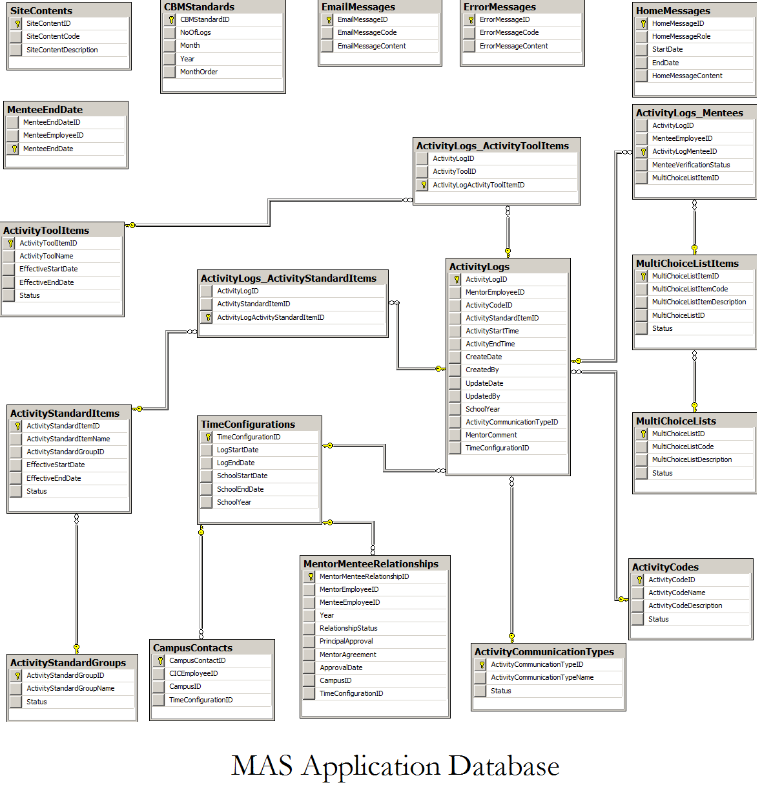

## mas application data flow

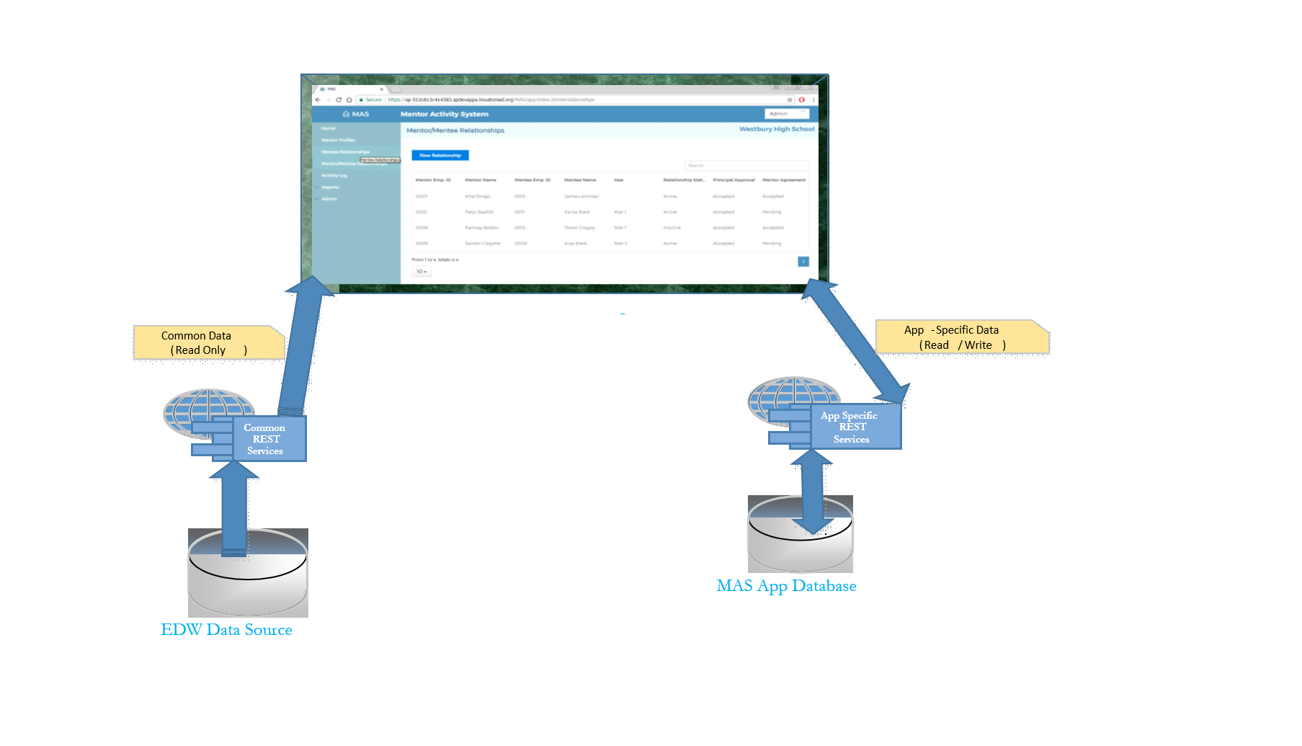

MAS Application data flow architecture

**Mentor Activity System User Interface**

**(SharePoint 2013 and React JS)**

# rest service specification

## common rest services

* + 1. Master data that is used in MAS application are exposed over common REST services.
       1. Service URL: <http://apidev.houstonisd.org/common/odata/> - all the common services are located here.

## mas application rest services

* + 1. Application specific data are stored in application database and exposed over transactional REST services.
       1. Service URL: <http://apidev.houstonisd.org/mas/odata/> - all the transactional services are located here.

## services (odata) consumption

* + 1. To access the entity data through services perfom the following requests on REST API
    2. COMMON REST SERVICES:

*[note: EXHIBITS are still been furnished over testing…]

* + - 1. EDUCATION ORGANIZATION

|  |  |  |  |
| --- | --- | --- | --- |
| ACTION | ODATA RESOURCE | INPUT | OUTPUT |
| GET | http://apidev.houstonisd.org/common/odata/EducationOrganizations | n/a | Collection of Education Organizations |
| GET | http://apidev.houstonisd.org/common/odata/EducationOrganizations('001')?$expand=SchoolManagers | EducationOrgNaturalKey | List of properties for an Education Organization and extends affiliated School Managers |
| GET | http://apidev.houstonisd.org/common/odata/EducationOrganizations('001')?$expand=SchoolManagers($expand=Up1Manager) | EducationOrgNaturalKey | List of properties for an Education Organization and extends affiliated SSO (Up1Manager) Info |
| GET | http://apidev.houstonisd.org/common/odata/EducationOrganizations('001')?$expand=SchoolManagers($expand=Up2Manager) | EducationOrgNaturalKey | List of properties for an Education Organization and extends affiliated CSO (Up2Manager) Info |
| GET | http://apidev.houstonisd.org/common/odata/EducationOrganizations('001')?$expand=SchoolManagers($expand=CILSchoolManager) | EducationOrgNaturalKey | List of properties for an Education Organization and extends affiliated PRINCIPAL (CILSchoolManager) Info |
| GET | http://apidev.houstonisd.org/common/odata/EducationOrganizations('287')?$expand=Staffs | EducationOrgNaturalKey | Collection of Staffs under an Education Organization |

* + - 1. STAFF

|  |  |  |  |
| --- | --- | --- | --- |
| ACTION | ODATA RESOURCE | INPUT | OUTPUT |
| GET | **http://apidev.houstonisd.org/common/odata/Staffs?top=10 | n/a | Collection of first 10 Staffs |
| GET | **http://apidev.houstonisd.org/common/odata/Staffs?top=10&$orderby=LastSurname | n/a | Collection of first 10 Staffs sorted by Last Name in asending order |
| GET | http://apidev.houstonisd.org/common/odata/Staffs('77029') | StaffNaturalKey | List of properties for a Staff |
| GET | http://apidev.houstonisd.org/common/odata/Staffs('10000')?$expand=StaffElectronicEmail | StaffNaturalKey | List of properties for a Staff and extends Staff Email Info |
| GET | http://apidev.houstonisd.org/common/odata/Staffs('39374')?$expand=JobFunction | StaffNaturalKey | List of properties for a Staff and extends Job Function Info |

** - experiences longer response time

* + - 1. STAFF ELECTRONIC EMAIL

|  |  |  |  |
| --- | --- | --- | --- |
| ACTION | ODATA RESOURCE | INPUT | OUTPUT |
| GET | http://apidev.houstonisd.org/common/odata/StaffElectronicEmails?$top=10 | n/a | Collection of first 10 Staff Email Info |

* + - 1. USER INFO

|  |  |  |  |
| --- | --- | --- | --- |
| ACTION | ODATA RESOURCE | INPUT | OUTPUT |
| GET | http://apidev.houstonisd.org/common/api/UserInfo | n/a | List of Active directory groups the user belongs to |

* + 1. **MAS APPLICATON REST SERVICES** 
       1. MENTORS

|  |  |  |  |
| --- | --- | --- | --- |
| ACTION | ODATA RESOURCE | INPUT | OUTPUT |
| GET | http://apidev.houstonisd.org/common/odata/EducationOrganizations('104')?$expand=Staffs | EducationOrgNaturalKey | Collection of Staffs as Mentors under an Education Organization |
| GET | http://apidev.houstonisd.org/common/odata/Staffs('39374')?$expand=JobFunction,StaffElectronicEmail,SchoolManagers($expand=EducationOrganization,CILSchoolManager) | MentorEmployeeID | List of properties for a Mentor, it extends affiliated Job Function, Email, Education Organization and Principal Info |
| GET | http://apidev.houstonisd.org/mas/odata/GetMentorsInActiveRelationshipByCampusID(CampusID='104') | CampusID | Collection of Mentors within a campus under active Mentor-Mentee Relationships |

* + - 1. MENTEES

|  |  |  |  |
| --- | --- | --- | --- |
| ACTION | ODATA RESOURCE | INPUT | OUTPUT |
| GET | http://apidev.houstonisd.org/mas/odata/GetMentees | n/a | Collection of Mentees |
| GET | http://apidev.houstonisd.org/mas/odata/GetMentees?$filter=FirstName eq 'Erika'&orderby=LastSurname desc | n/a | Collection of Mentees based on Filter and sort criteria |
| GET | http://apidev.houstonisd.org/mas/odata/GetMenteesByCampusID(CampusID='104') | EducationOrgNaturalKey | Collection of Mentees under an Education Organization(Campus) |
| GET | http://apidev.houstonisd.org/common/odata/Staffs('39374')?$expand=JobFunction,StaffElectronicEmail,SchoolManagers($expand=EducationOrganization,CILSchoolManager) | MenteeEmployeeID | List of properties for a Mentee, it extends affiliated Job Function, Email, Education Organization and Principal Info |
| GET | http://apidev.houstonisd.org/mas/odata/GetMenteesInActiveRelationshipByMentorID(EmployeeID='1255') | MentorEmployeeID | Collection of Mentees under a Mentor and in an active Mentor-Mentee Relationships |

* + - 1. MENTOR MENTEE RELATONSHIPS

|  |  |  |  |
| --- | --- | --- | --- |
| ACTION | ODATA RESOURCE | INPUT | OUTPUT |
| GET | http://apidev.houstonisd.org/mas/odata/MentorMenteeRelationships | n/a | Collection of existing Mentor-Mentee Relationships |
| GET | http://apidev.houstonisd.org/mas/odata/MentorMenteeRelationships?$expand=TimeConfiguration&$filter=TimeConfigurationID eq 1 | TimeConfigurationID | Collection of Mentor-Mentee Relationships within a Time Configuration |
| GET | http://apidev.houstonisd.org/mas/odata/MentorMenteeRelationships?$expand=TimeConfiguration&$filter=CampusID eq '001' | EducationOrgNaturalKey | Collection of Mentor-Mentee Relationships under an Education Organization(Campus) |
| GET | http://apidev.houstonisd.org/mas/odata/MentorMenteeRelationships?$expand=TimeConfiguration&$filter=CampusID eq '001' and TimeConfigurationID eq 1 | EducationOrgNaturalKey and TimeConfigurationID | Collection of of Mentor-Mentee Relationships under an Education Organization(Campus) within a Time Configuration(School Year) |
| GET | http://apidev.houstonisd.org/mas/odata/MentorMenteeRelationships?$expand=TimeConfiguration&$filter=MentorEmployeeID eq '00110014' | MentorEmployeeID | Collection of of Mentor-Mentee Relationships for a Mentor |
| GET | http://apidev.houstonisd.org/mas/odata/MentorMenteeRelationships?$expand=TimeConfiguration&$filter=MenteeEmployeeID eq '104953' | MenteeEmployeeID | List of Mentor-Mentee Relationship proterties for a Mentee |
| GET | http://apidev.houstonisd.org/mas/odata/GetAllMentorMenteeRelationships?$filter= EducationOrgNaturalKey eq '104' | CampusID | Collection of Active Mentor-Mentee Relationships within a Campus |
| GET | http://apidev.houstonisd.org/mas/odata/GetAllMentorMenteeRelationships?$filter= MentorEmployeeID eq '1255' | MentorEmployeeID | Collection of active Mentor-Mentee Relationships for a Mentor |
| GET | http://apidev.houstonisd.org/mas/odata/GetMentorsInActiveRelationshipByCampusID(CampusID='104') | CampusID | List of Mentors in Active Relationship within a Campus |
| GET | http://apidev.houstonisd.org/mas/odata/GetMenteesInActiveRelationshipByMentorID(EmployeeID='1255') | MentorEmployeeID | List of Mentees under a Mentor in an active Mentor-Mentee Relationships |

* + - 1. MENTEE END DATE

|  |  |  |  |
| --- | --- | --- | --- |
| ACTION | ODATA RESOURCE | INPUT | OUTPUT |
| GET | http://apidev.houstonisd.org/mas/odata/MenteeEndDates | n/a | Collection of existing Mentee End Dates |
| GET | http://apidev.houstonisd.org/mas/odata/MenteeEndDates(10) | MenteeEndDateID | List of properties for a Mentee End Date Configuration |
| POST | http://apidev.houstonisd.org/mas/odata/MenteeEndDates | EXHIBIT 4.3.3.4-A | A Mentee End Date (resource) will be created into Database table |
| PUT | http://apidev.houstonisd.org/mas/odata/ MenteeEndDates (10) | MenteeEndDateID &  EXHIBIT 4.3.3.4-B | An existing Mentee End Date source will be modified (full Update) |
| PATCH | http://apidev.houstonisd.org/mas/odata/ MenteeEndDates (10) | MenteeEndDateID &  EXHIBIT 4.3.3.4-C | An existing Mentee End Date resource will be modified (partial Update) |
| DELETE | http://apidev.houstonisd.org/mas/odata/ MenteeEndDates (10) | MenteeEndDateID &  EXHIBIT 4.3.3.4-D | An existing Mentee End Date resource will be Deleted |
| GET | http://apidev.houstonisd.org/mas/odata/GetAllMenteeEndDates | n/a | Collection of existing Mentee End Dates and it's Details |

* + - 1. CAMPUS CONTACTS

|  |  |  |  |
| --- | --- | --- | --- |
| ACTION | ODATA RESOURCE | INPUT | OUTPUT |
| GET | http://apidev.houstonisd.org/mas/odata/CampusContacts | n/a | Collection of existing Campus Contacts |
| GET | http://apidev.houstonisd.org/mas/odata/CampusContacts?$filter=CampusID eq '104' | EducationOrgNaturalKey | Collection of Campus Contacts for an Education Organization(Campus) |
| GET | http://apidev.houstonisd.org/mas/odata/CampusContacts?$filter=CampusID eq '104' and TimeConfigurationID eq 1 | EducationOrgNaturalKey and TimeConfigurationID | Collection of Campus Contacts under an Education Organization(Campus) within a Time Configuration (School Year) |
| GET | http://apidev.houstonisd.org/mas/odata/GetCampusContactsByCampusID(CampusID='104') | CampusID | Collection of Campus Contacts Details info under an Education Organization |
| GET | http://apidev.houstonisd.org/mas/odata/GetAllCampusContacts | n/a | Collection of all existing Campus Contacgts Info Details |
| POST | http://apidev.houstonisd.org/mas/odata/CampusContacts | EXHIBIT 4.3.3.5-A | A Campus Contact entry (resource) will be created into Database table |
| PUT | http://apidev.houstonisd.org/mas/odata/CampusContacts(6) | CampusContactID &  EXHIBIT 4.3.3.5-B | An existing Campus Contact resource will be modified (full Update) |
| PATCH | http://apidev.houstonisd.org/mas/odata/CampusContacts(6) | CampusContactID &  EXHIBIT 4.3.3.5-C | An existing Campus Contact resource will be modified (partial Update) |
| DELETE | http://apidev.houstonisd.org/mas/odata/CampusContacts(6) | CampusContactID &  EXHIBIT 4.3.3.5-D | An existing Campus Contact resource will be Deleted |

* + - 1. SITE CONTENTS

|  |  |  |  |
| --- | --- | --- | --- |
| ACTION | ODATA RESOURCE | INPUT | OUTPUT |
| GET | http://apidev.houstonisd.org/mas/odata/SiteContents | n/a | Collection of existing Site Contents |
| GET | http://apidev.houstonisd.org/mas/odata/SiteContents(11) | SiteContentID | List of properties for a Site Content Configuration |
| POST | http://apidev.houstonisd.org/mas/odata/SiteContents | EXHIBIT 4.3.3.6-A | A Site Content entry (resource) will be created into Database table |
| PUT | http://apidev.houstonisd.org/mas/odata/SiteContents(1020) | SiteContentID  &  EXHIBIT 4.3.3.6-B | An existing Site Content resource will be modified (full Update) |
| PATCH | http://apidev.houstonisd.org/mas/odata/SiteContents(1021) | SiteContentID  &  EXHIBIT 4.3.3.6-C | An existing Site Content resource will be modified (partial Update) |
| DELETE | http://apidev.houstonisd.org/mas/odata/SiteContents(1022) | SiteContentID  &  EXHIBIT 4.3.3.6-D | An existing Site Content resource will be Deleted |

* + - 1. HOME MESSAGES

|  |  |  |  |
| --- | --- | --- | --- |
| ACTION | ODATA RESOURCE | INPUT | OUTPUT |
| GET | http://apidev.houstonisd.org/mas/odata/HomeMessages | n/a | Collection of existing Home Messages |
| GET | http://apidev.houstonisd.org/mas/odata/ HomeMessages(1) | HomeMessageID | List of properties for a Home Message Configuration |
| POST | http://apidev.houstonisd.org/mas/odata/HomeMessages | EXHIBIT 4.3.3.7-A | A Home Message entry (resource) will be created into Database table |
| PUT | http://apidev.houstonisd.org/mas/odata/HomeMessages(DemoID) | HomeMessageID &  EXHIBIT 4. 3.3.7-B | An existing Home Message resource will be modified (full Update) |
| PATCH | http://apidev.houstonisd.org/mas/odata/HomeMessages(DemoID) | HomeMessageID &  EXHIBIT 4. 3.3.7-C | An existing Home Message resource will be modified (partial Update) |
| DELETE | http://apidev.houstonisd.org/mas/odata/ HomeMessages(DemoID) | HomeMessageID &  EXHIBIT 4. 3.3.7-D | An existing Home Message resource will be Deleted |

* + - 1. EMAIL MESSAGES

|  |  |  |  |
| --- | --- | --- | --- |
| ACTION | ODATA RESOURCE | INPUT | OUTPUT |
| GET | http://apidev.houstonisd.org/mas/odata/EmailMessages | n/a | Collection of existing Email Messages |
| GET | http://apidev.houstonisd.org/mas/odata/ EmailMessages(1) | EmailMessageID | List of properties for an Email Message Configuration |
| POST | http://apidev.houstonisd.org/mas/odata/EmailMessages | EXHIBIT 4.3.3.8-A | An Email Message entry (resource) will be created into Database table |
| PUT | http://apidev.houstonisd.org/mas/odata/EmailMessages(DemoID) | EmailMessageID &  EXHIBIT 4. 3.3.8-B | An existing Email Message resource will be modified (full Update) |
| PATCH | http://apidev.houstonisd.org/mas/odata/EmailMessages(DemoID) | EmailMessageID &  EXHIBIT 4. 3.3.8-C | An existing Email Message resource will be modified (partial Update) |
| DELETE | http://apidev.houstonisd.org/mas/odata/ EmailMessages(DemoID) | EmailMessageID &  EXHIBIT 4. 3.3.8-D | An existing Email Message resource will be Deleted |

* + - 1. ERROR MESSAGES

|  |  |  |  |
| --- | --- | --- | --- |
| ACTION | ODATA RESOURCE | INPUT | OUTPUT |
| GET | http://apidev.houstonisd.org/mas/odata/ErrorMessages | n/a | Collection of existing Error Messages |
| GET | http://apidev.houstonisd.org/mas/odata/ ErrorMessages(1) | ErrorMessageID | List of properties for a Error Message Configuration |
| POST | http://apidev.houstonisd.org/mas/odata/ErrorMessages | EXHIBIT 4.3.3.9-A | An Error Message entry (resource) will be created into Database table |
| PUT | http://apidev.houstonisd.org/mas/odata/ErrorMessages(DemoID) | HomeMessageID &  EXHIBIT 4. 3.3.9-B | An existing Error Message resource will be modified (full Update) |
| PATCH | http://apidev.houstonisd.org/mas/odata/ErrorMessages(DemoID) | HomeMessageID &  EXHIBIT 4. 3.3.9-C | An existing Error Message resource will be modified (partial Update) |
| DELETE | http://apidev.houstonisd.org/mas/odata/ ErrorMessages(DemoID) | HomeMessageID &  EXHIBIT 4. 3.3.9-D | An existing Error Message resource will be Deleted |

* + - 1. TIME CONFIGURATIONS

|  |  |  |  |
| --- | --- | --- | --- |
| ACTION | ODATA RESOURCE | INPUT | OUTPUT |
| GET | http://apidev.houstonisd.org/mas/odata/TimeConfigurations | n/a | Collection of existing TimeConfigurations |
| GET | http://apidev.houstonisd.org/mas/odata/ TimeConfigurations (1) | TimeConfigurationID | List of properties for a TimeConfiguration |
| POST | http://apidev.houstonisd.org/mas/odata/ TimeConfigurations | EXHIBIT 4.3.3.10-A | A TimeConfiguration entry (resource) will be created into Database table |
| PUT | http://apidev.houstonisd.org/mas/odata/ TimeConfigurations (DemoID) | TimeConfigurationID &  EXHIBIT 4.3.3.10-B | An existing TimeConfigurations resource will be modified (full Update) |
| PATCH | http://apidev.houstonisd.org/mas/odata/ TimeConfigurations (DemoID) | TimeConfigurationID &  EXHIBIT 4.3.3.10-C | An existing TimeConfiguration resource will be modified (partial Update) |
| DELETE | http://apidev.houstonisd.org/mas/odata/ TimeConfigurations (DemoID) | TimeConfigurationID &  EXHIBIT 4.3.3.10-D | An existing TimeConfiguration resource will be Deleted |

* + - 1. CBM STANDARDS

|  |  |  |  |
| --- | --- | --- | --- |
| ACTION | ODATA RESOURCE | INPUT | OUTPUT |
| GET | http://apidev.houstonisd.org/mas/odata/CBMStandards | n/a | Collection of existing CBM Standards |
| GET | http://apidev.houstonisd.org/mas/odata/ CBMStandards(1) | CBMStandardID | List of properties for a CBM Standard Configuration |
| POST | http://apidev.houstonisd.org/mas/odata/ CBMStandards(DemoID) | EXHIBIT 4.3.3.11-A | A CBM Standard entry (resource) will be created into Database table |
| PUT | http://apidev.houstonisd.org/mas/odata/ CBMStandards(DemoID) | CBMStandardID &  EXHIBIT 4.3.3.11-B | An existing CBM Standard resource will be modified (full Update) |
| PATCH | http://apidev.houstonisd.org/mas/odata/ CBMStandards(DemoID)) | CBMStandardID &  EXHIBIT 4.3.3.11-C | An existing CBM Standard resource will be modified (partial Update) |
| DELETE | http://apidev.houstonisd.org/mas/odata/ CBMStandards(DemoID) | CBMStandardID &  EXHIBIT 4.3.3.11-D | An existing CBM Standard resource will be Deleted |

* + - 1. ACTIVITY CODES

|  |  |  |  |
| --- | --- | --- | --- |
| ACTION | ODATA RESOURCE | INPUT | OUTPUT |
| GET | http://apidev.houstonisd.org/mas/odata/ActivityCodes | n/a | Collection of existing Activity Codes |
| GET | http://apidev.houstonisd.org/mas/odata/ ActivityCodes(2) | ActivityCodeID | List of properties for an Activity Code Configuration |
| POST | http://apidev.houstonisd.org/mas/odata/ ActivityCodes | EXHIBIT 4.3.3.12-A | An Activity Codeentry (resource) will be created into Database table |
| PUT | http://apidev.houstonisd.org/mas/odata/ ActivityCodes (DemoID) | ActivityCodeID &  EXHIBIT 4.3.3.12-B | An existing Activity Code resource will be modified (full Update) |
| PATCH | http://apidev.houstonisd.org/mas/odata/ ActivityCodes (DemoID) | ActivityCodeID &  EXHIBIT 4.3.3.12-C | An existing Activity Code resource will be modified (partial Update) |
| DELETE | http://apidev.houstonisd.org/mas/odata/ ActivityCodes (DemoID) | ActivityCodeID &  EXHIBIT 4.3.3.12A-D | An existing Activity Code resource will be Deleted |

* + - 1. ACTIVITY STANDARD GROUPS

|  |  |  |  |
| --- | --- | --- | --- |
| ACTION | ODATA RESOURCE | INPUT | OUTPUT |
| GET | http://apidev.houstonisd.org/mas/odata/ActivityStandardGroups | n/a | Collection of existing Activity Standard Groups |
| GET | http://apidev.houstonisd.org/mas/odata/ActivityStandardGroups(1) | ActivityStandardGroupID | List of properties for an Activity Standard Group Configuration |
| GET | http://apidev.houstonisd.org/mas/odata/ActivityStandardGroups?$expand=ActivityStandardItems | n/a | Collection of existing Activity Standard Groups with Activity Standard Items |
| GET | http://apidev.houstonisd.org/mas/odata/ActivityStandardGroups(2)?$expand=ActivityStandardItems | ActivityStandardGroupID | Collection of existing Activity Standard Items within an Activity Standard Group |
| POST | http://apidev.houstonisd.org/mas/odata/ActivityStandardGroups | EXHIBIT 4.3.3.13-A | An Activity Standard Group entry (resource) will be created into Database table |
| PUT | http://apidev.houstonisd.org/mas/odata/ ActivityStandardGroups(DemoID) | ActivityStandardGroupID &  EXHIBIT 4.3.3.13-B | An existing Activity Standard Group resource will be modified (full Update) |
| PATCH | http://apidev.houstonisd.org/mas/odata/ ActivityStandardGroups(DemoID) | ActivityStandardGroupID &  EXHIBIT 4.3.3.13-C | An existing Activity Standard Group resource will be modified (partial Update) |
| DELETE | http://apidev.houstonisd.org/mas/odata/ ActivityStandardGroups(DemoID) | ActivityStandardGroupID &  EXHIBIT 4.3.3.13-D | An existing Activity Standard Group resource will be Deleted |

* + - 1. ACTIVITY STANDARD ITEMS

|  |  |  |  |
| --- | --- | --- | --- |
| ACTION | ODATA RESOURCE | INPUT | OUTPUT |
| GET | http://apidev.houstonisd.org/mas/odata/ActivityStandardItems | n/a | Collection of existing Activity Standard Items |
| GET | http://apidev.houstonisd.org/mas/odata/ActivityStandardItems(31) | ActivityStandardItemID | List of properties for an Activity Standard Item Configuration |
| GET | http://apidev.houstonisd.org/mas/odata/ActivityStandardItems(31)?$expand=ActivityStandardGroup | ActivityStandardItemID | List of properties for an Activity Standard Item Configuration and expands associated Acitivity Standard Group Info |
| POST | http://apidev.houstonisd.org/mas/odata/ActivityStandardItems | EXHIBIT 4.3.3.14-A | An Activity Standard Item entry (resource) will be created into Database table |
| PUT | http://apidev.houstonisd.org/mas/odata/ ActivityStandardItems(DemoID) | ActivityStandardItemID &  EXHIBIT 4.3.3.14-B | An existing Activity Standard Item resource will be modified (full Update) |
| PATCH | http://apidev.houstonisd.org/mas/odata/ ActivityStandardItemID  (DemoID) | ActivityStandardItemID &  EXHIBIT 4.3.3.14-C | An existing Activity Standard Item resource will be modified (partial Update) |
| DELETE | http://apidev.houstonisd.org/mas/odata/ ActivityStandardItems(DemoID) | ActivityStandardItemID &  EXHIBIT 4.3.3.14-D | An existing Activity Standard Item resource will be Deleted |

* + - 1. ACTIVITY TOOL ITEMS

|  |  |  |  |
| --- | --- | --- | --- |
| ACTION | ODATA RESOURCE | INPUT | OUTPUT |
| GET | http://apidev.houstonisd.org/mas/odata/ActivityToolItems | n/a | Collection of existing Activity Tool Items |
| GET | http://apidev.houstonisd.org/mas/odata/ActivityToolItems(1) | ActivityToolItemID | List of properties for an Activity Tool Item Configuration |
| POST | http://apidev.houstonisd.org/mas/odata/ActivityToolItems | EXHIBIT 4.3.3.15-A | An Activity Tool Item entry (resource) will be created into Database table |
| PUT | http://apidev.houstonisd.org/mas/odata/ ActivityToolItems (DemoID) | ActivityToolItemID & EXHIBIT 4.3.3.15-B | An existing Activity Tool Item resource will be modified (full Update) |
| PATCH | http://apidev.houstonisd.org/mas/odata/ ActivityToolItems (DemoID) | ActivityToolItemID & EXHIBIT 4.3.3.15-C | An existing Activity Tool Item resource will be modified (partial Update) |
| DELETE | http://apidev.houstonisd.org/mas/odata/ ActivityToolItems (DemoID) | ActivityToolItemID & EXHIBIT 4.3.3.15-D | An existing Activity Tool Item resource will be Deleted |

* + - 1. ACTIVITY LOGS

|  |  |  |  |
| --- | --- | --- | --- |
| ACTION | ODATA RESOURCE | INPUT | OUTPUT |
| GET | http://apidev.houstonisd.org/mas/odata/GetAllActivityLogs | n/a | Collection of existing Activity Logs expand all affiliated entities (I.e.: Mentees, Tool Items, Standard Items) |
| GET | http://apidev.houstonisd.org/mas/odata/GetActivityLogsByCampusID(CampusID='104') | CampusID | Collection of Activity Logs within a Campus expand all affiliated entities (I.e.: Mentees, Tool Items, Standard Items) |
| GET | http://apidev.houstonisd.org/mas/odata/GetActivityLogsByCampusID(CampusID='104')?$expand=Mentees |  | Collection of Activity Logs within a Campus expands affiliated Mentees |
| GET | http://apidev.houstonisd.org/mas/odata/GetActivityLogsByCampusID(CampusID='104')?$expand=ActivityStandardItems | CampusID | Collection of Activity Logs within a Campus expands affiliated Activity Standard Items |
| GET | http://apidev.houstonisd.org/mas/odata/GetActivityLogsByCampusID(CampusID='104')?$expand=ActivityToolItems | CampusID | Collection of Activity Logs within a Campus expands affiliated Activity Tool Items |
| POST | http://apidev.houstonisd.org/mas/odata/ActivityLogs | EXHIBIT 4.3.3.16-A | An Activity Tool Item entry (resource) will be created into Database table |
| PUT | http://apidev.houstonisd.org/mas/odata/ ActivityLogs (DemoID) | ActivityLogID & EXHIBIT 4.3.3.16-B | An existing Activity Tool Item resource will be modified (full Update) |
| PATCH | http://apidev.houstonisd.org/mas/odata/ ActivityLogs (DemoID) | ActivityLogID & EXHIBIT 4.3.3.16-C | An existing Activity Tool Item resource will be modified (partial Update) |
| DELETE | http://apidev.houstonisd.org/mas/odata/ ActivityLogs (DemoID) | ActivityLogID & EXHIBIT 4.3.3.16-D | An existing Activity Tool Item resource will be Deleted |
| POST | http://apidev.houstonisd.org/mas/odata/CreateActivityLog | EXHIBIT 4.3.3.16-E | WIP - (Create an Actiity Log and affiliated Enities – Mentees+Activity Standard Items+ Activity Tool Items) |
| PUT | http://apidev.houstonisd.org/mas/odata/ UpdateActivityLogs (DemoID) | ActivityLogID & EXHIBIT 4.3.3.16-F | WIP - (Update an Actiity Log and affiliated Enities – Mentees+Activity Standard Items+ Activity Tool Items) |
| PATCH | http://apidev.houstonisd.org/mas/odata/ UpdateActivityLogs (DemoID) | ActivityLogID & EXHIBIT 4.3.3.16-G | WIP - (Update an Actiity Log and affiliated Enities – Mentees+Activity Standard Items+ Activity Tool Items) |
| DELETE | http://apidev.houstonisd.org/mas/odata/ DeleteActivityLogs (DemoID) | ActivityLogID & EXHIBIT 4.3.3.16-H | WIP - (Delete an Actiity Log and affiliated Enities – Mentees+Activity Standard Items+ Activity Tool Items |

* + - 1. MULTI-CHOICE LISTS

|  |  |  |  |
| --- | --- | --- | --- |
| ACTION | ODATA RESOURCE | INPUT | OUTPUT |
| GET | http://apidev.houstonisd.org/mas/odata/MultiChoiceLists | n/a | Collection of existing Multi-Choice Lists |
| GET | http://apidev.houstonisd.org/mas/odata/ MultiChoiceLists(1) | MultiChoiceListID | List of properties for a Multi-Choice List Configuration |
| GET | http://apidev.houstonisd.org/mas/odata/MultiChoiceLists(1)?$expand=MultiChoiceListItems | MultiChoiceListID | Collection of Multi-Choice List Items within a Multi-Choice List |
| POST | http://apidev.houstonisd.org/mas/odata/MultiChoiceLists | EXHIBIT 4.3.3.17-A | A Multi-Choice List entry (resource) will be created into Database table |
| PUT | http://apidev.houstonisd.org/mas/odata/ MultiChoiceLists (DemoID) | MultiChoiceListID & EXHIBIT 4.3.3.17-B | An existing Multi-Choice List resource will be modified (full Update) |
| PATCH | http://apidev.houstonisd.org/mas/odata/ MultiChoiceLists (DemoID) | MultiChoiceListID & EXHIBIT 4.3.3.17-C | An existing Multi-Choice List resource will be modified (partial Update) |
| DELETE | http://apidev.houstonisd.org/mas/odata/ MultiChoiceLists (DemoID) | MultiChoiceListID & EXHIBIT 4.3.3.17-D | An existing Multi-Choice List resource will be Deleted |

* + - 1. MULTI-CHOICE LIST ITEMS

|  |  |  |  |
| --- | --- | --- | --- |
| ACTION | ODATA RESOURCE | INPUT | OUTPUT |
| GET | http://apidev.houstonisd.org/mas/odata/MultiChoiceLists | n/a | Collection of existing Multi-Choice Lists |
| GET | http://apidev.houstonisd.org/mas/odata/ MultiChoiceLists(1) | MultiChoiceListItemID | List of properties for a Multi-Choice List Configuration |
| GET | http://apidev.houstonisd.org/mas/odata/MultiChoiceLists(1)?$expand=MultiChoiceListItems($filter=MultiChoiceListItemCode eq 'Item-One-Code') | MultiChoiceListItemCode | Get Details of a Specific Multichoice List Item |
| POST | http://apidev.houstonisd.org/mas/odata/MultiChoiceListItems | EXHIBIT 4.3.3.18-A | A Multi-Choice List Item entry (resource) will be created into Database table |
| PUT | <http://apidev.houstonisd.org/mas/odata/MultiChoiceListItems(1002>) | MultiChoiceListItemID & EXHIBIT 4.3.3.17-B | An existing Multi-Choice List Item resource will be modified (full Update) |
| PATCH | http://apidev.houstonisd.org/mas/odata/MultiChoiceListItems(1002)) | MultiChoiceListItemID& EXHIBIT 4.3.3.17-C | An existing Multi-Choice List Item resource will be modified (partial Update) |
| DELETE | http://apidev.houstonisd.org/mas/odata/MultiChoiceListItems (DemoID)) | MultiChoiceListItemID& EXHIBIT 4.3.3.17-D | An existing Multi-Choice List Item resource will be Deleted |

* + 1. REPORTING MODULE

For reporting Modules MAS application reqires several custom services to be built. To meet the data needs we need data to be pulled from both MAS application Data storage and HISD master Data storage and do the necessary manipulation for report view. The services that are developed are listed below:

* + - 1. ACTIVITY TOTAL

|  |  |  |  |
| --- | --- | --- | --- |
| ACTION | ODATA RESOURCE | INPUT | OUTPUT |
| GET | http://apidev.houstonisd.org/mas/odata/GetActivityLogsTotalTime | n/a | Accumulated Total time of Activity Logs spent by Mentors per School Office and affiliated CSO |

* + - 1. MENTOR ACTIVITY LOG

|  |  |  |  |
| --- | --- | --- | --- |
| ACTION | ODATA RESOURCE | INPUT | OUTPUT |
| GET | http://apidev.houstonisd.org/mas/odata/GetAllActivityLogs?$expand=Mentees,ActivityToolItems,ActivityStandardItems&orderby MentorFirstName desc | n/a | List of all the Acitivitis entered by the Mentors (Admin scope) |
| GET | http://apidev.houstonisd.org/mas/odata/GetActivityLogsByCampusID(CampusID='104')?$expand=Mentees,ActivityToolItems,ActivityStandardItems& order by =MentorFirstName | CampusID | List of all the Acitivitis entered by the Mentors under a School (Principal/CIC scope) |
| GET | <http://apidev.houstonisd.org/mas/odata/GetActivityLogsByCampusID(CampusID='104')?$filter=MentorEmployeeID> eq '19639' &$expand=Mentees,ActivityToolItems,ActivityStandardItems | CampusID & MentorEmployeeID | List of all the Acitivitis entered by a Mentor (Mentor scope) |

* + - 1. MENTOR COMPLETION REPORT

|  |  |  |  |
| --- | --- | --- | --- |
| ACTION | ODATA RESOURCE | INPUT | OUTPUT |
| GET | *http://apidev.houstonisd.org/mas/odata/GetActivityLogsCompletedByMentor | n/a | Calculates the total no of logs complted by each Mentor and Met Reqirement Status (Admin Scope) |
| GET | *http://apidev.houstonisd.org/mas/odata/GetActivityLogsCompletedByMentor?$filter=EducationOrgNaturalKey eq '104' | CampusID | Calculates the total no of logs complted by each Mentor and Met Reqirement Status(Principal/CIC scope) |
| GET | *http://apidev.houstonisd.org/mas/odata/GetActivityLogsCompletedByMentor?$filter=(EducationOrgNaturalKey eq '104' and MentorEmployeeID eq '1255') | CampusID and MentorEmployeeID | Calculates the total no of logs complted by each Mentor and Met Reqirement Status(Mentor) |

**\*- there are some changes received on BRD – will be addressed.**

* + - 1. VERIFICATION STANDARDS & TOOLS

|  |  |  |  |
| --- | --- | --- | --- |
| ACTION | ODATA RESOURCE | INPUT | OUTPUT |
| GET | http://apidev.houstonisd.org/mas/odata/GetAllActivityLogs?$expand=Mentees,ActivityToolItems,ActivityStandardItems | n/a | Listing activity Logs with extension of Verification by Mentees |
| GET | http://apidev.houstonisd.org/mas/odata/GetAllActivityLogs?$expand=Mentees($filter=VerificationStatus eq 'Yes'),ActivityToolItems,ActivityStandardItems | n/a | Listing activity Logs that are Verified by Mentees |
| GET | http://apidev.houstonisd.org/mas/odata/GetAllActivityLogs?$expand=Mentees($filter=VerificationStatus eq 'No'),ActivityToolItems,ActivityStandardItems | n/a | Listing activity Logs that are not Verified by Mentees |

* + - 1. MENTOR/MENTEE DEMOGRAFIC REPORT

|  |  |  |  |
| --- | --- | --- | --- |
| ACTION | ODATA RESOURCE | INPUT | OUTPUT |
| GET | http://apidev.houstonisd.org/mas/odata/GetAllMentorMenteeRelationships | n/a | List all existing MentorMentee Relationships under HISD with demographic information |
| GET | http://apidev.houstonisd.org/mas/odata/GetAllMentorMenteeRelationships?$filter= EducationOrgNaturalKey eq '104' | EducationOrgNaturalKey | List all existing MentorMentee Relationships under a School with demographic information |

# EXHIBITS

* 1. SITE CONTENTS – EXHIBITS
     1. EXHIBIT 4.3.3.6-A

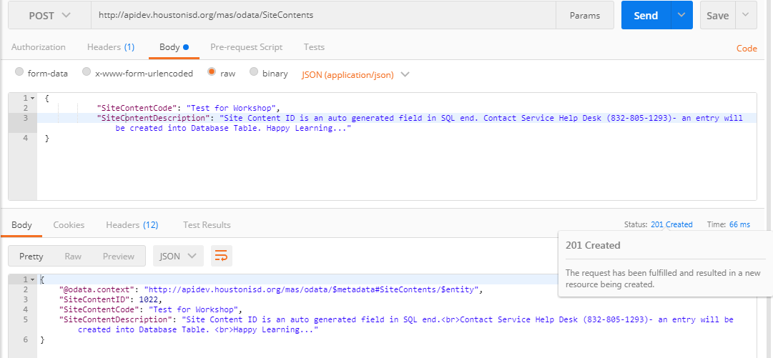

* + 1. EXHIBIT 4.3.3.6-B

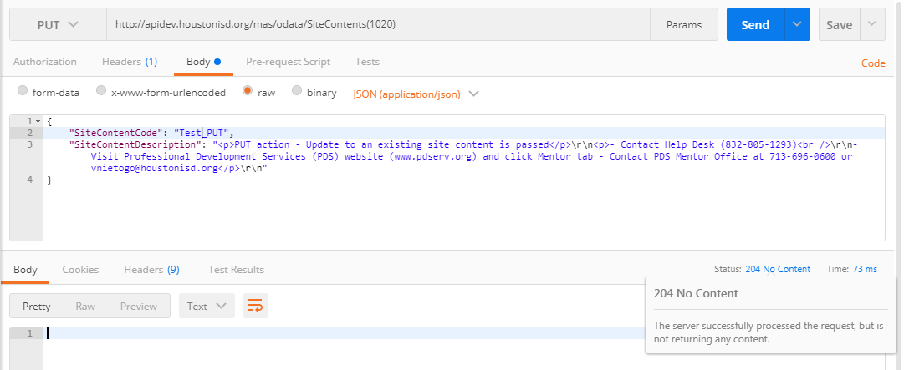

* + 1. EXHIBIT 4.3.3.6-C

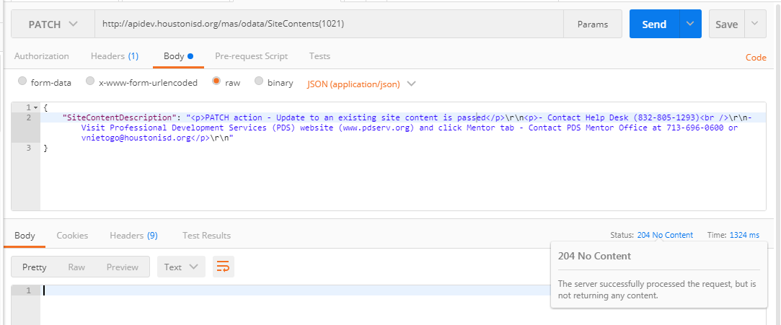

* + 1. EXHIBIT 4.3.3.6-D

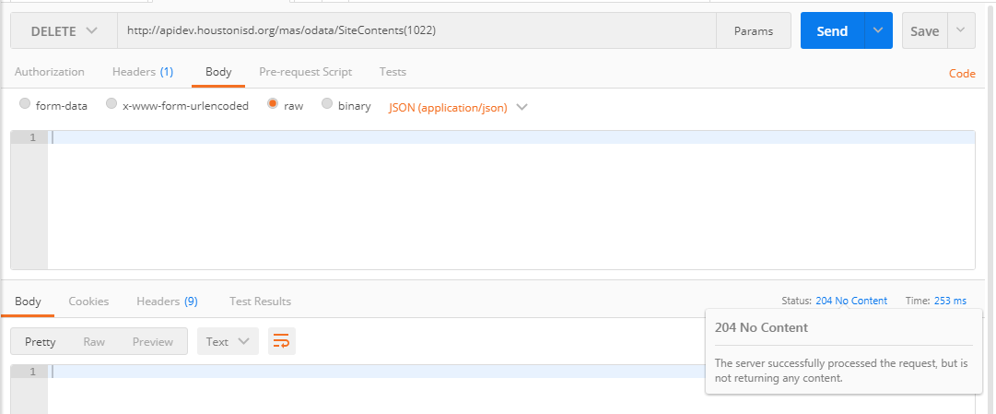

* 1. HOME MESSAGES – EXHIBITS
     1. EXHIBIT 4.3.3.7-A

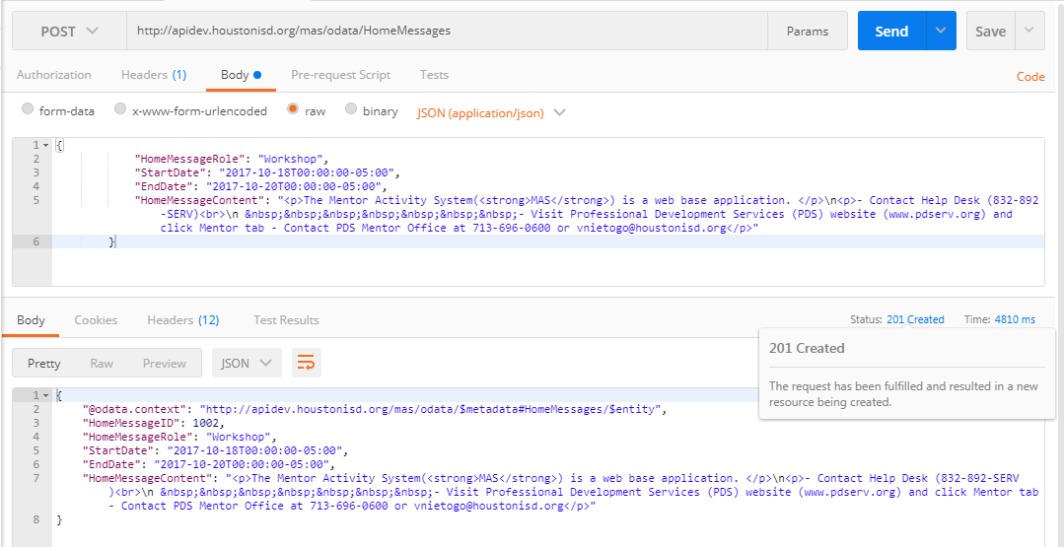

* + 1. EXHIBIT 4.3.3.7-B

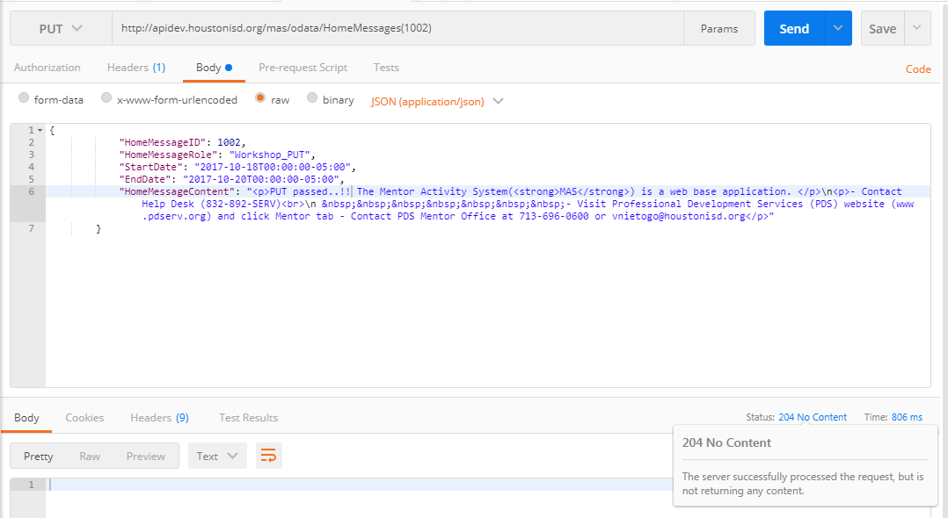

* + 1. EXHIBIT 4.3.3.7-C

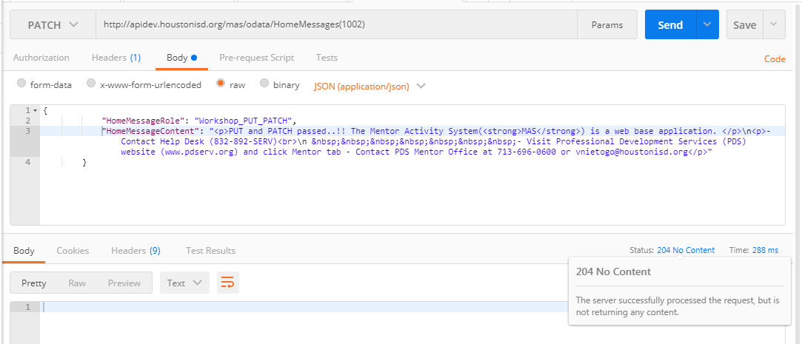

* + 1. EXHIBIT 4.3.3.7-D

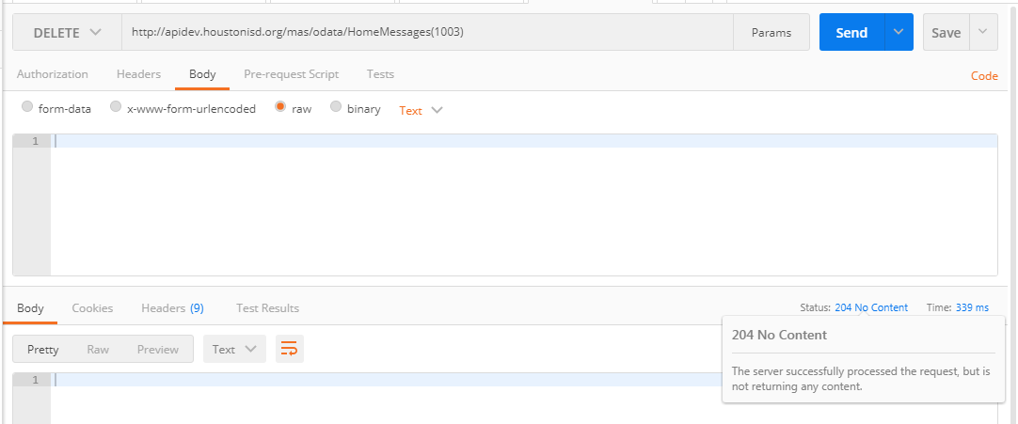

* 1. EMAIL MESSAGES – EXHIBITS [DEMO]
     1. EXHIBIT 4.3.3.8-A
     2. EXHIBIT 4.3.3.8-B
     3. EXHIBIT 4.3.3..8-C
     4. EXHIBIT 4.3.3.8-D
  2. ERROR MESSAGES – EXHIBITS [DEMO]
     1. EXHIBIT 4.3.3.9-A
     2. EXHIBIT 4.3.3.9-B
     3. EXHIBIT 4.3.3.9-C
     4. EXHIBIT 4.3.3.9-D
  3. TIME CONFIGURATIONS – EXHIBITS [DEMO]
     1. EXHIBIT 4.3.3.10-A
     2. EXHIBIT 4.3.3.10-B
     3. EXHIBIT 4.3.3.10-C
     4. EXHIBIT 4.3.3.10-D
  4. CBM STANDARDS – EXHIBITS [DEMO]
     1. EXHIBIT 4.3.3.11-A
     2. EXHIBIT 4.3.3.11-B
     3. EXHIBIT 4.3.3.11-C
     4. EXHIBIT 4.3.3.11-D
  5. REMAINING EXHIBITS WILL BE INPUTED BY PERFORMING DEMO

# Tutorial for service access

## tools

* + 1. Install Google Chrome
    2. Install Postman (or any other rest clients)

<https://app.getpostman.com/app/download/win64?_ga=2.256334027.1910367814.1509580150-1257223781.1509580150>

## steps

* + 1. Select Action over Postman to interact with resource
    2. Input service endpoint address URI
    3. Fix request Header/Body parameters
    4. Fix response content negotiation (i.e. XML or JSON) and receive response contents for a request (See EXHIBIT section)
    5. Check the status code issued by server after action is performed

## related readings

* + 1. <http://www.odata.org/documentation/odata-version-2-0/uri-conventions/>
    2. <http://www.odata.org/getting-started/basic-tutorial/>
    3. <http://www.odata.org/getting-started/advanced-tutorial/>

# acknowledgement

* + 1. Thanks to HISD SharePoint Application Development team for the guide and supports
    2. Cortesy to Anil for Common REST services
    3. Courtesy to Jerome for document template